2. Library Book Management System
Features Required:
1) Add books, issue books, return books
2) Display Stock
3) Maintain fine calculation using loops
Concepts to be Used: Arrays, loops, File handling


TEAM :
25A31A05DH PARNA JAYAVARDHAN
25A31A05BJ BASA KAVYA SRI
25A31A05BP JAMI MANOJA
25A31A05CX KARRA JAYA SURYA
25A31A05DI PATTA CHARAN SATYANANDA VIVEK VARMA

📘 Library Book Management System – Documentation

1. Introduction

The Library Book Management System is a simple C-language project designed to help manage basic library operations such as maintaining book records, issuing and returning books, and calculating fines. The project uses arrays, loops, and file handling to store and manage book data efficiently.
This system is intended for academic learning and demonstrates the use of fundamental programming concepts.
--------------------------------------------------------------------------------------------------

2. Objectives

- To maintain a database of books using arrays and files.

- To provide functions for adding, issuing, and returning books.

- To display available stock of books.

- To calculate fine for late returns using loops.

--------------------------------------------------------------------------------------------------

3. System Features

  - 3.1 Add Books

The librarian can add new books by entering:
- Book ID :

- Book Title :

- Author Name :

- Quantity :

Data is stored using arrays and also saved to a file for future use.

  - 3.2 Issue Books

A student can issue a book using its Book ID.

The system checks:
- If the book exists
- If stock is available
If available:
Quantity decreases by 1

Issue details (student name, book ID, issue date) are stored in a file

  - 3.3 Return Books

A student returns a book by entering the Book ID.
The system:
- Increases the book quantity
- Asks for the number of days the book was kept
- Calculates the fine if days exceed the limit (example: 14 days)
  - 3.4 Fine Calculation
Fine is calculated using loops.
Example logic:
if(days > 14) //days>issue period
fine = (days - 14) * 2;
else
fine = 0;

The fine details are displayed to the user.

  - 3.5 Display Stock

Shows the list of all books in the library:
Book ID :
Title :
Author :
Available Quantity :

Uses loops to traverse the array of book.

----------------------------------------------------------------

4. Technology & Concepts Used

  - 4.1 C Programming Concepts

- Arrays: To store book structures, multiple book records

- Loops: Displaying books, fine calculation, searching book IDs

- Conditional Statements

- Functions: For modularity ( addBook(), issueBook(), returnBook() )

  - 4.2 File Handling

To store book records permanently
Files used:
- books.txt → stores book list
- issued.txt → stores issued book information
--------------------------------------------------------------------------------------------------

5. System Design

  - 5.1 Data Structures

Book Structure
struct Book ;
{
int id;
char title[50];
char author[50];
int quantity;
};
Issued Book Structure
struct Issue
{
int bookId;
char studentName[50];
int issueDay;
int returnDay;
};
--------------------------------------------------------------------------------------------------

6. Workflow

Main Menu

1. Add Book
2. Issue Book
3. Return Book
4. Display Stock
5. Exit
Each option executes a separate function.
--------------------------------------------------------------------------------------------------

7. File Handling Approach
- Saving Books
- Write array of books to file after adding a book.
- Saving Issued Records
- Append each new issued book entry to issued.txt.
- Updating After Return
- When a book is returned, update stock in memory and overwrite the file.
--------------------------------------------------------------------------------------------------

8. Sample Output (Console)
---- Library Book Management System ----

1. Add Book
2. Issue Book
3. Return Book
4. Display Stock
5. Exit
Enter choice: 2
Enter Book ID to issue: 101
Book issued successfully!

9. Conclusion

This project demonstrates how to build a simple management system using arrays, loops, and file handling in C. It is useful for understanding real-world applications of basic programming principles.
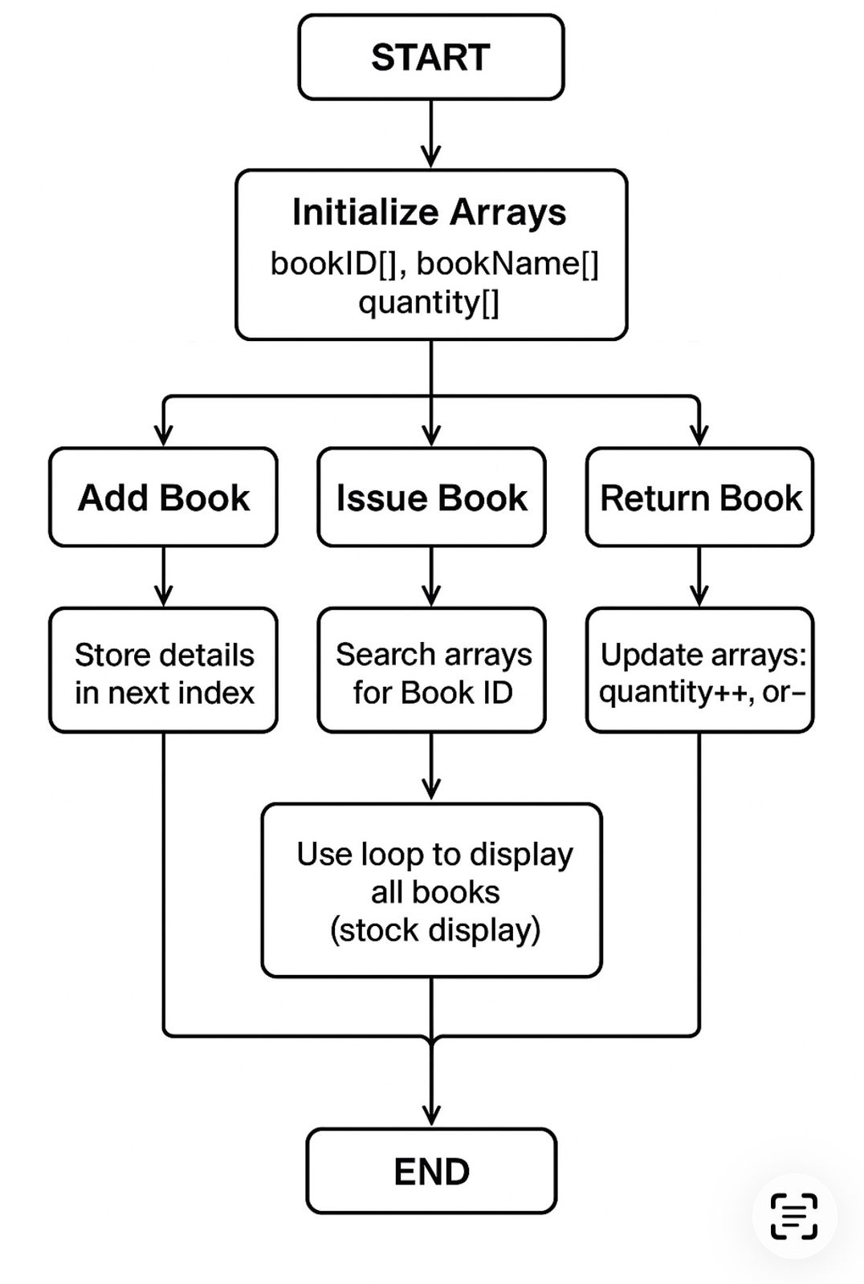
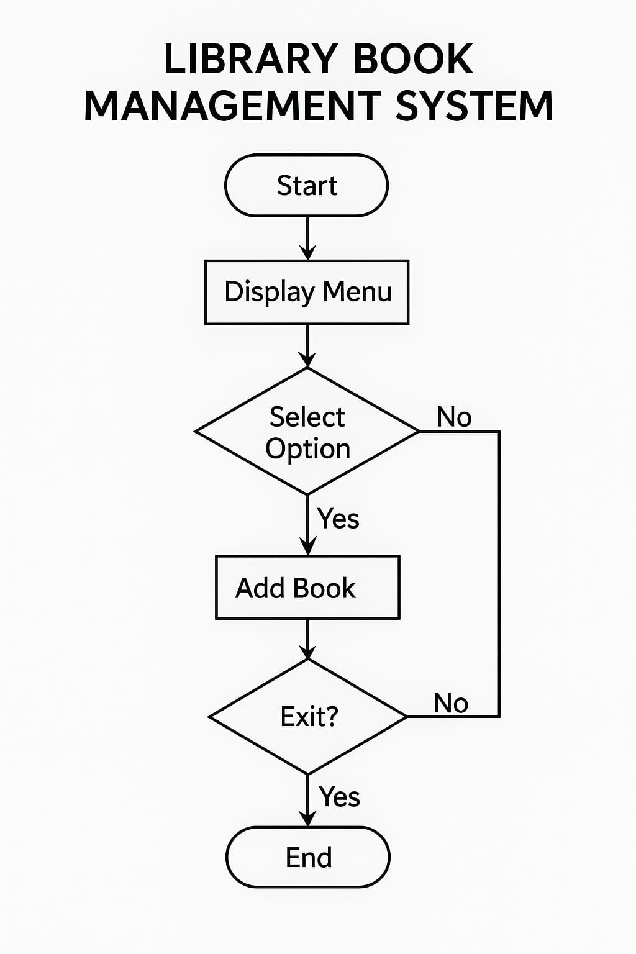

SAMPLE CODE
#include <stdio.h>
#include <string.h>

struct Book {
int id;
char title[50];
char author[50];
int quantity;
};

struct Issue {
int bookId;
char student[50];
int days;
};

struct Book books[100];
int bookCount = 0;

void saveBooksToFile() {
FILE *fp = fopen("books.txt", "w");
for (int i = 0; i < bookCount; i++) {
fprintf(fp, "%d %s %s %d\n", books[i].id, books[i].title,
books[i].author, books[i].quantity);
}
fclose(fp);
}

void loadBooksFromFile() {
FILE *fp = fopen("books.txt", "r");
if (fp == NULL) return;

bookCount = 0;
while (fscanf(fp, "%d %s %s %d",
&books[bookCount].id,
books[bookCount].title,
books[bookCount].author,
&books[bookCount].quantity) != EOF) {
bookCount++;
}
fclose(fp);
}

void addBook() {
printf("\nEnter Book ID: ");
scanf("%d", &books[bookCount].id);

printf("Enter Title: ");
scanf("%s", books[bookCount].title);

printf("Enter Author: ");
scanf("%s", books[bookCount].author);

printf("Enter Quantity: ");
scanf("%d", &books[bookCount].quantity);

bookCount++;
saveBooksToFile();

printf("\nBook Added Successfully!\n");
}

void displayStock() {
printf("\n---- Available Books ----\n");
for (int i = 0; i < bookCount; i++) {
printf("ID: %d Title: %s Author: %s Quantity: %d\n",
books[i].id, books[i].title, books[i].author, books[i].quantity);
}
}

void issueBook() {
int id, found = -1;

printf("\nEnter Book ID to Issue: ");
scanf("%d", &id);

for (int i = 0; i < bookCount; i++) {
if (books[i].id == id) {
found = i;
break;
}
}

if (found == -1) {
printf("\nBook Not Found!\n");
return;
}

if (books[found].quantity == 0) {
printf("\nBook Out of Stock!\n");
return;
}

char student[50];
printf("Enter Student Name: ");
scanf("%s", student);

FILE *fp = fopen("issued.txt", "a");

fprintf(fp, "%d %s\n", id, student);
fclose(fp);

books[found].quantity--;
saveBooksToFile();

printf("\nBook Issued Successfully!\n");
}

void returnBook() {
int id, found = -1;

printf("\nEnter Book ID to Return: ");
scanf("%d", &id);

for (int i = 0; i < bookCount; i++) {
if (books[i].id == id) {
found = i;
break;
}
}

if (found == -1) {
printf("\nInvalid Book ID!\n");
return;
}

int days;
printf("Enter Number of Days Book was Taken: ");
scanf("%d", &days);

int fine = 0;

if (days > 14) {
int extra = days - 14;

// Fine calculation using loop
for (int i = 0; i < extra; i++) {
fine += 2; // ₹2 fine per day
}
}

books[found].quantity++;
saveBooksToFile();

printf("\nBook Returned Successfully!\n");
printf("Fine Amount = ₹%d\n", fine);
}

int main() {
int choice;
loadBooksFromFile();

while (1) {
printf("\n---- Library Book Management System ----\n");
printf("1. Add Book\n");
printf("2. Issue Book\n");
printf("3. Return Book\n");
printf("4. Display Stock\n");
printf("5. Exit\n");
printf("Enter your choice: ");
scanf("%d", &choice);

switch (choice) {
case 1: addBook(); break;
case 2: issueBook(); break;
case 3: returnBook(); break;
case 4: displayStock(); break;
case 5:
printf("\nExiting... Thank you!\n");
return 0;
default:
printf("\nInvalid Choice! Try Again.\n");
}
}

return 0;
}

